GDBART Puppy Test in a room procedure
Jan 16 2018

Materials required
- 2 See through dividers to partition space approximately 24 x 24 feet (i.e. exercise pens). 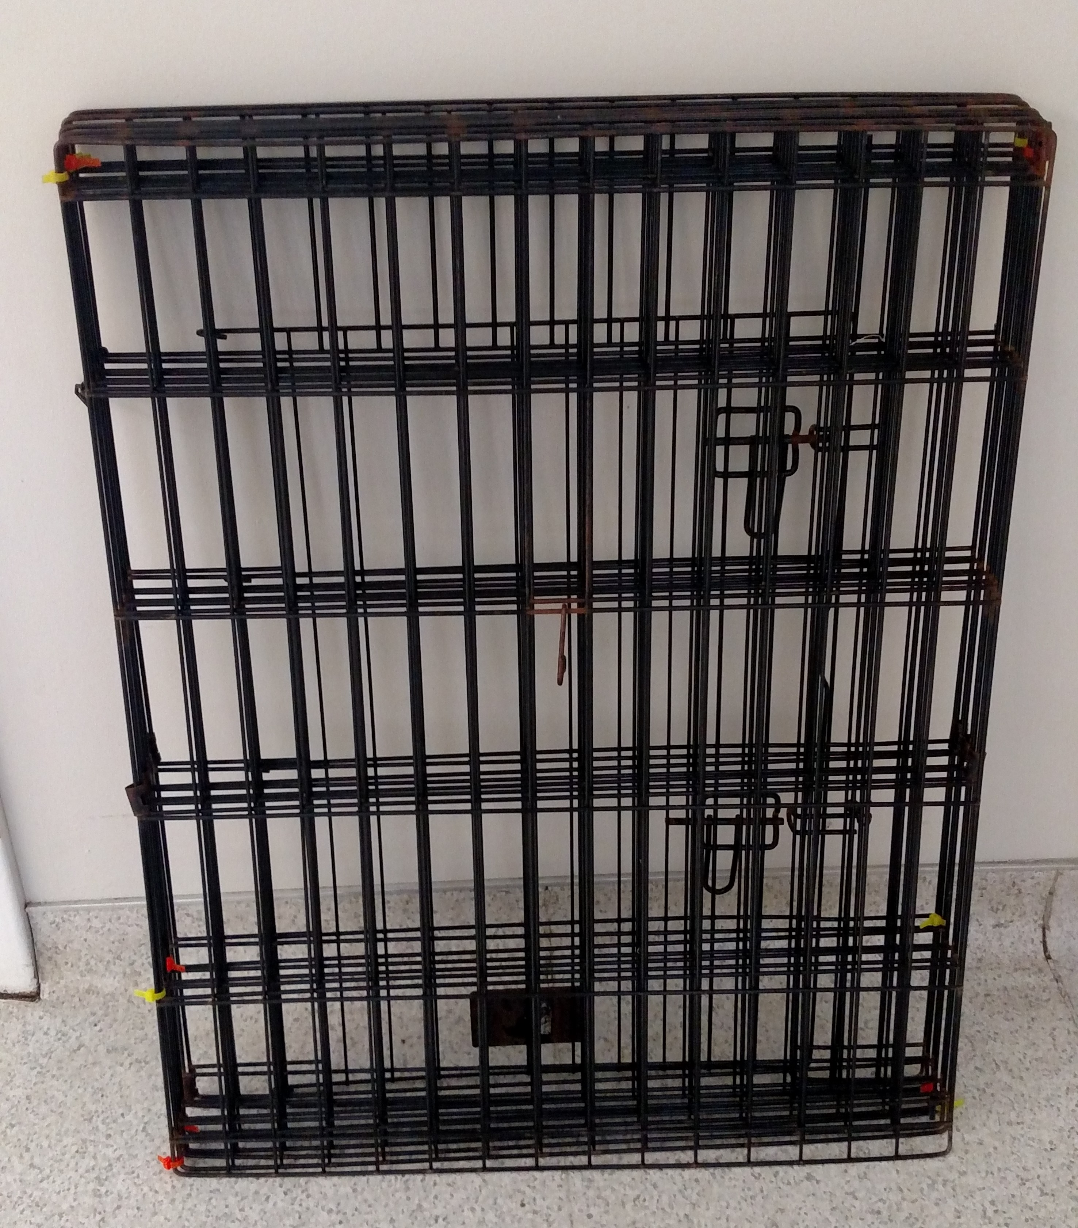
- Clock with a second hand
- Tripod and video recorder
- Kibble for puppy being tested.
- Novel objects: welcome dog (13”), small rabbit (11”), Yoda, Alligator, Angel
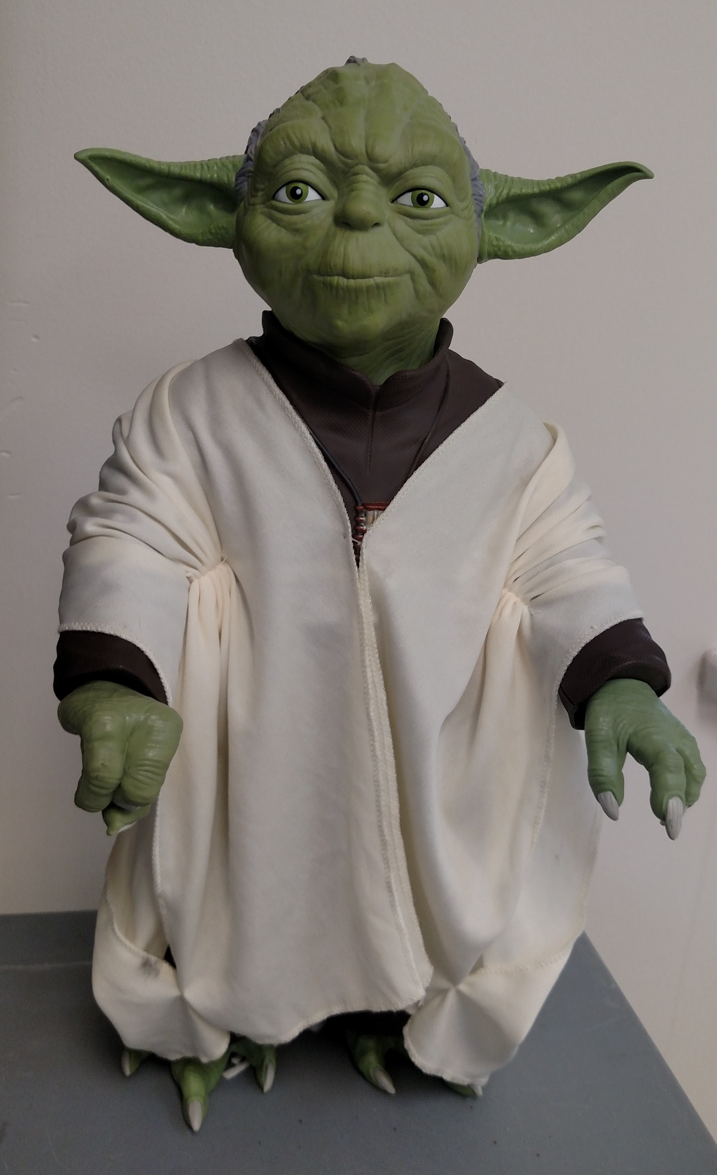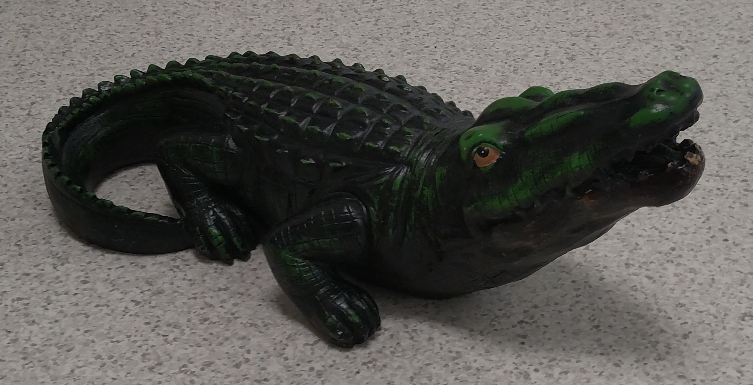
- Electric box fan 20” tall (med speed flow, quiet if possible).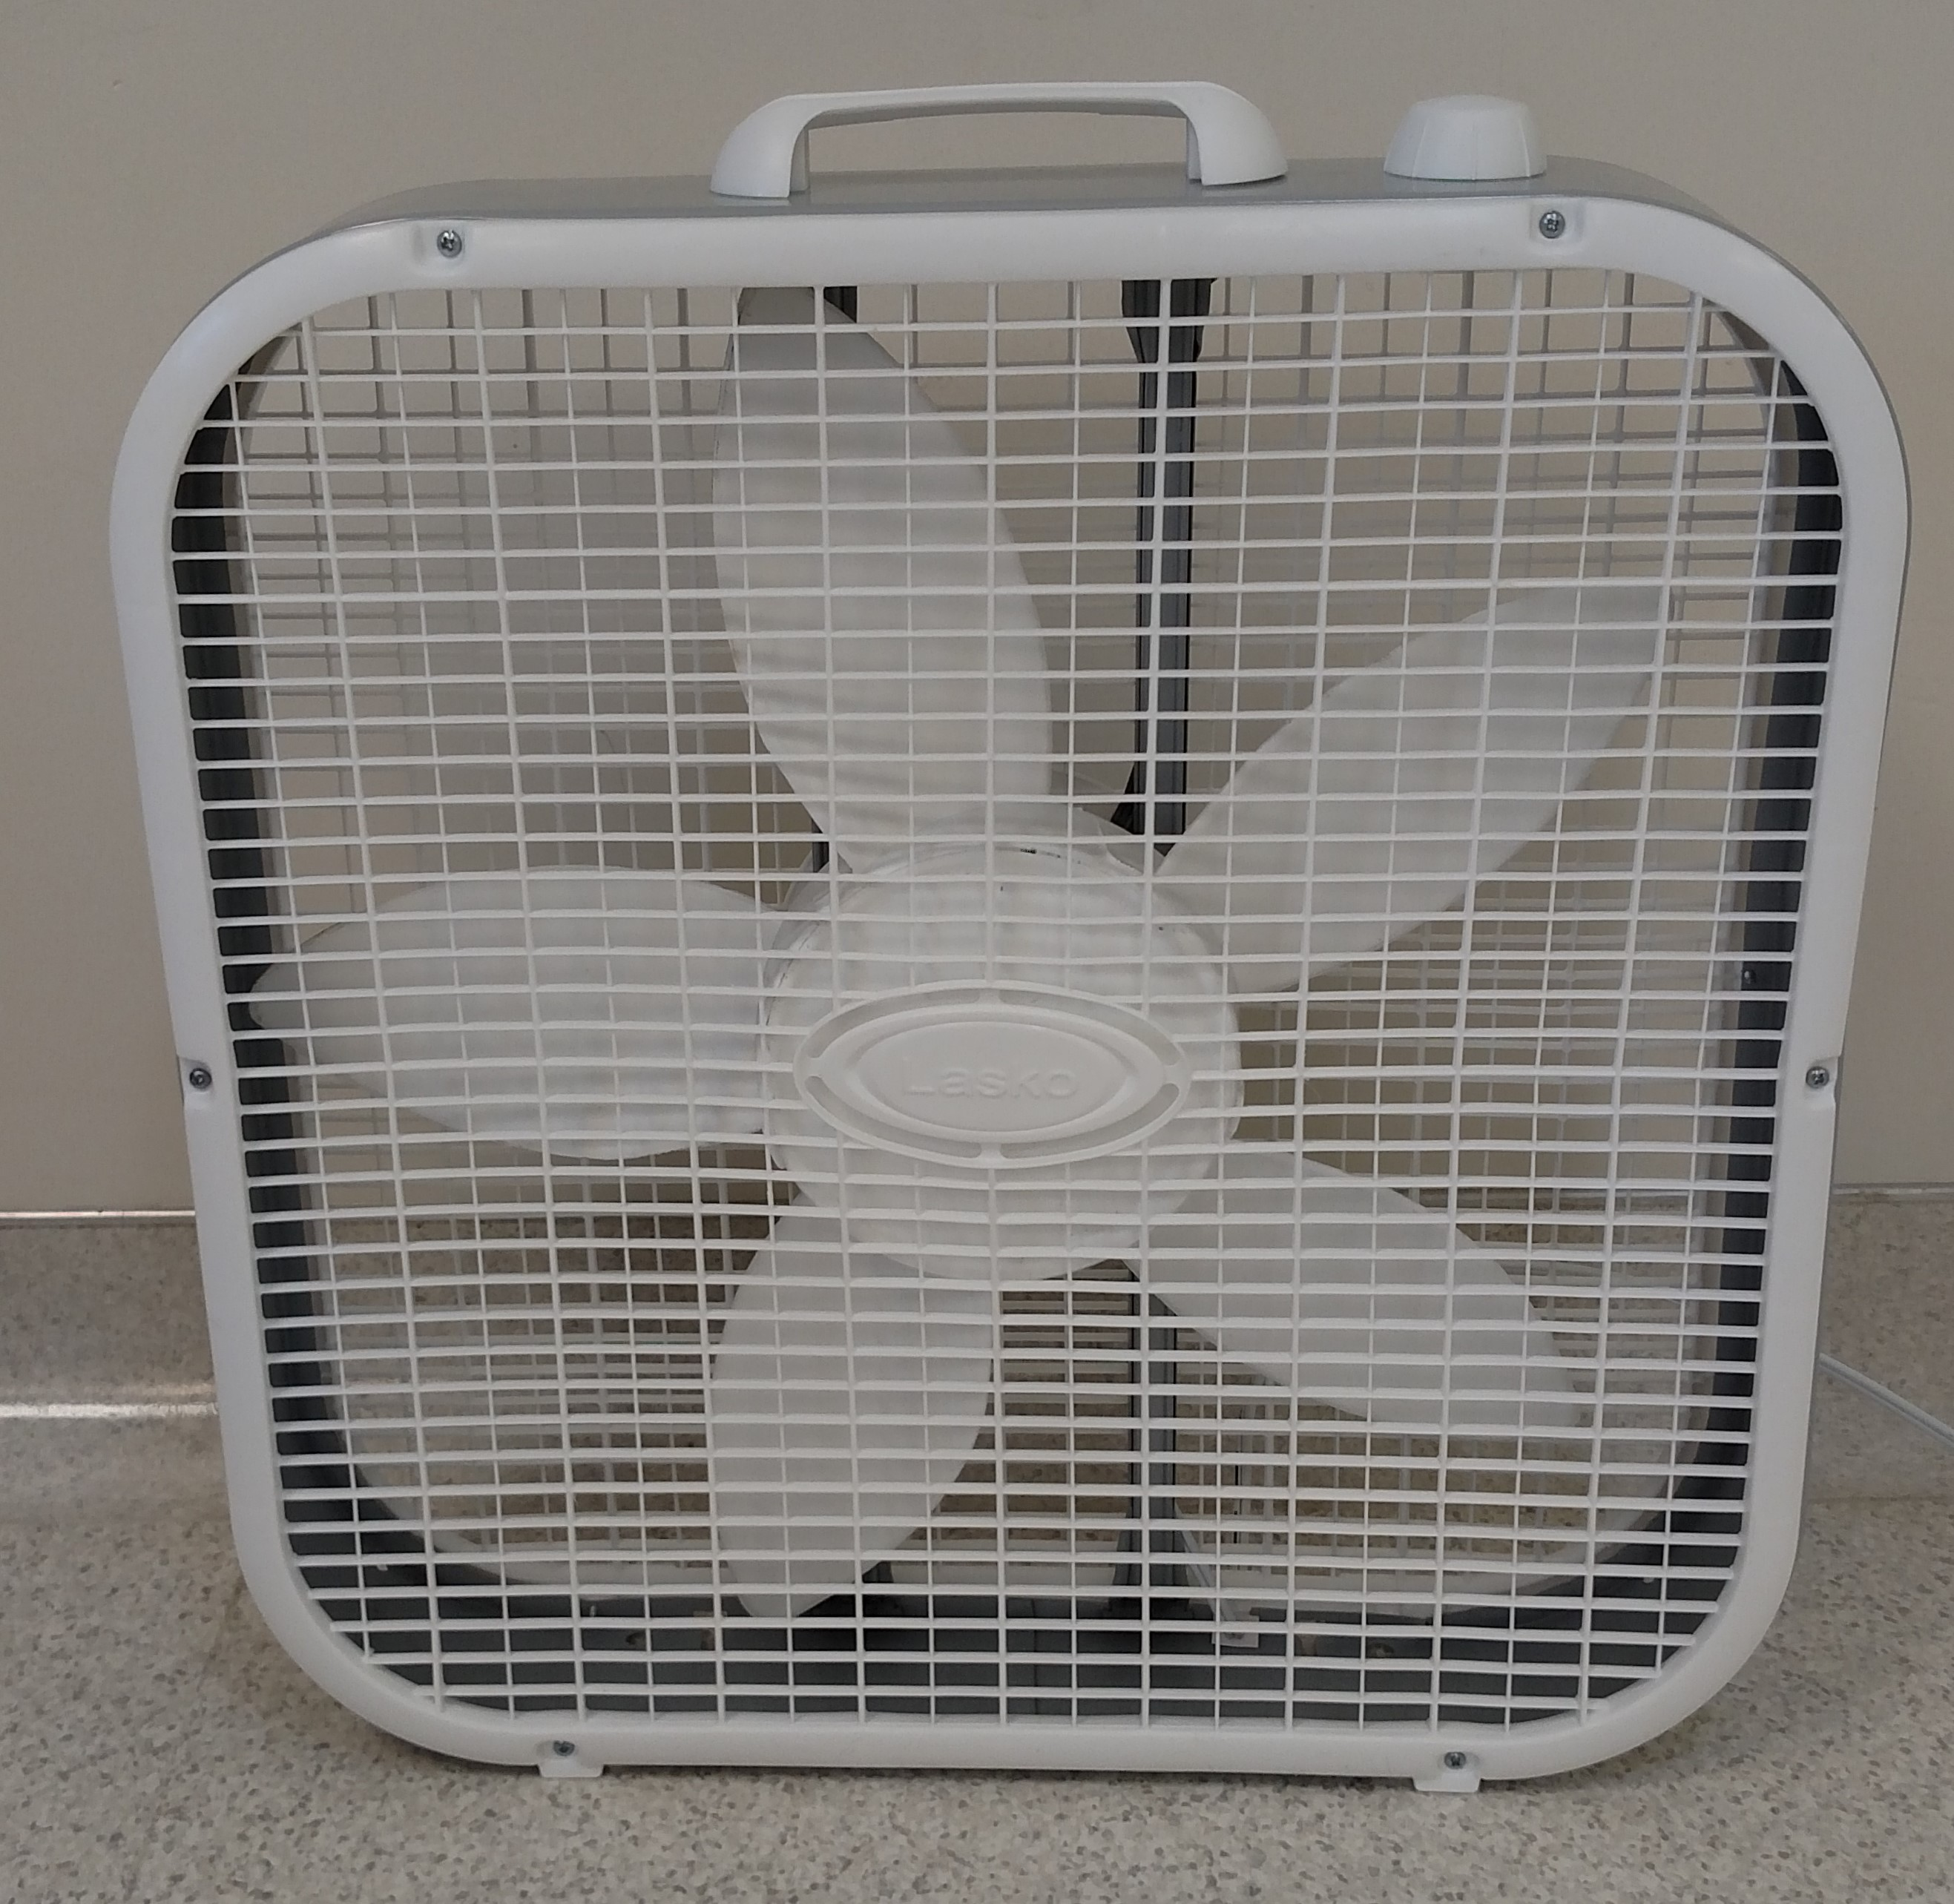
- Tunnel – 15” diameter corrugated drain pipe. Length – 30” 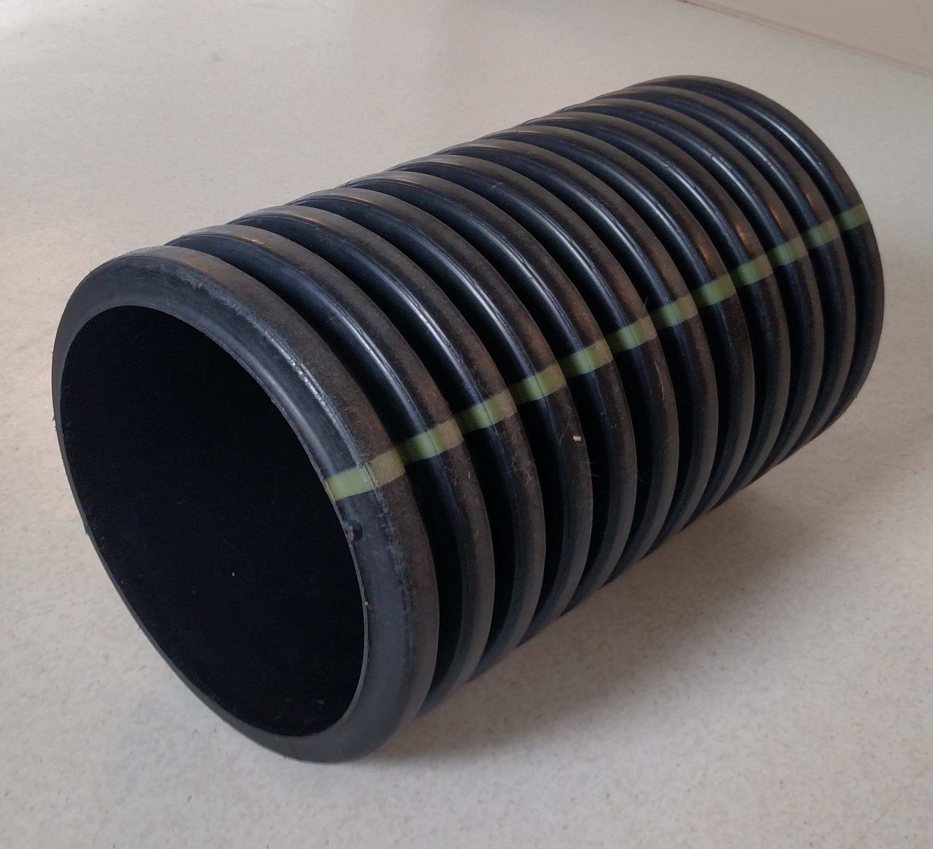

- Underfootings: place along wall with a few inches for the handler to step and guide pup over without stepping into the camera view, plastic bread grate, black rubber mat (You can substitute other items such as a section of exercise pen. approximately 28”x36”)
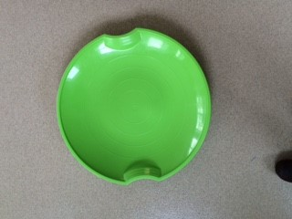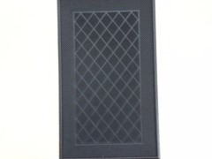
- Puppy sized stairs/ramp, ideally the pup can go up on one side and down the other 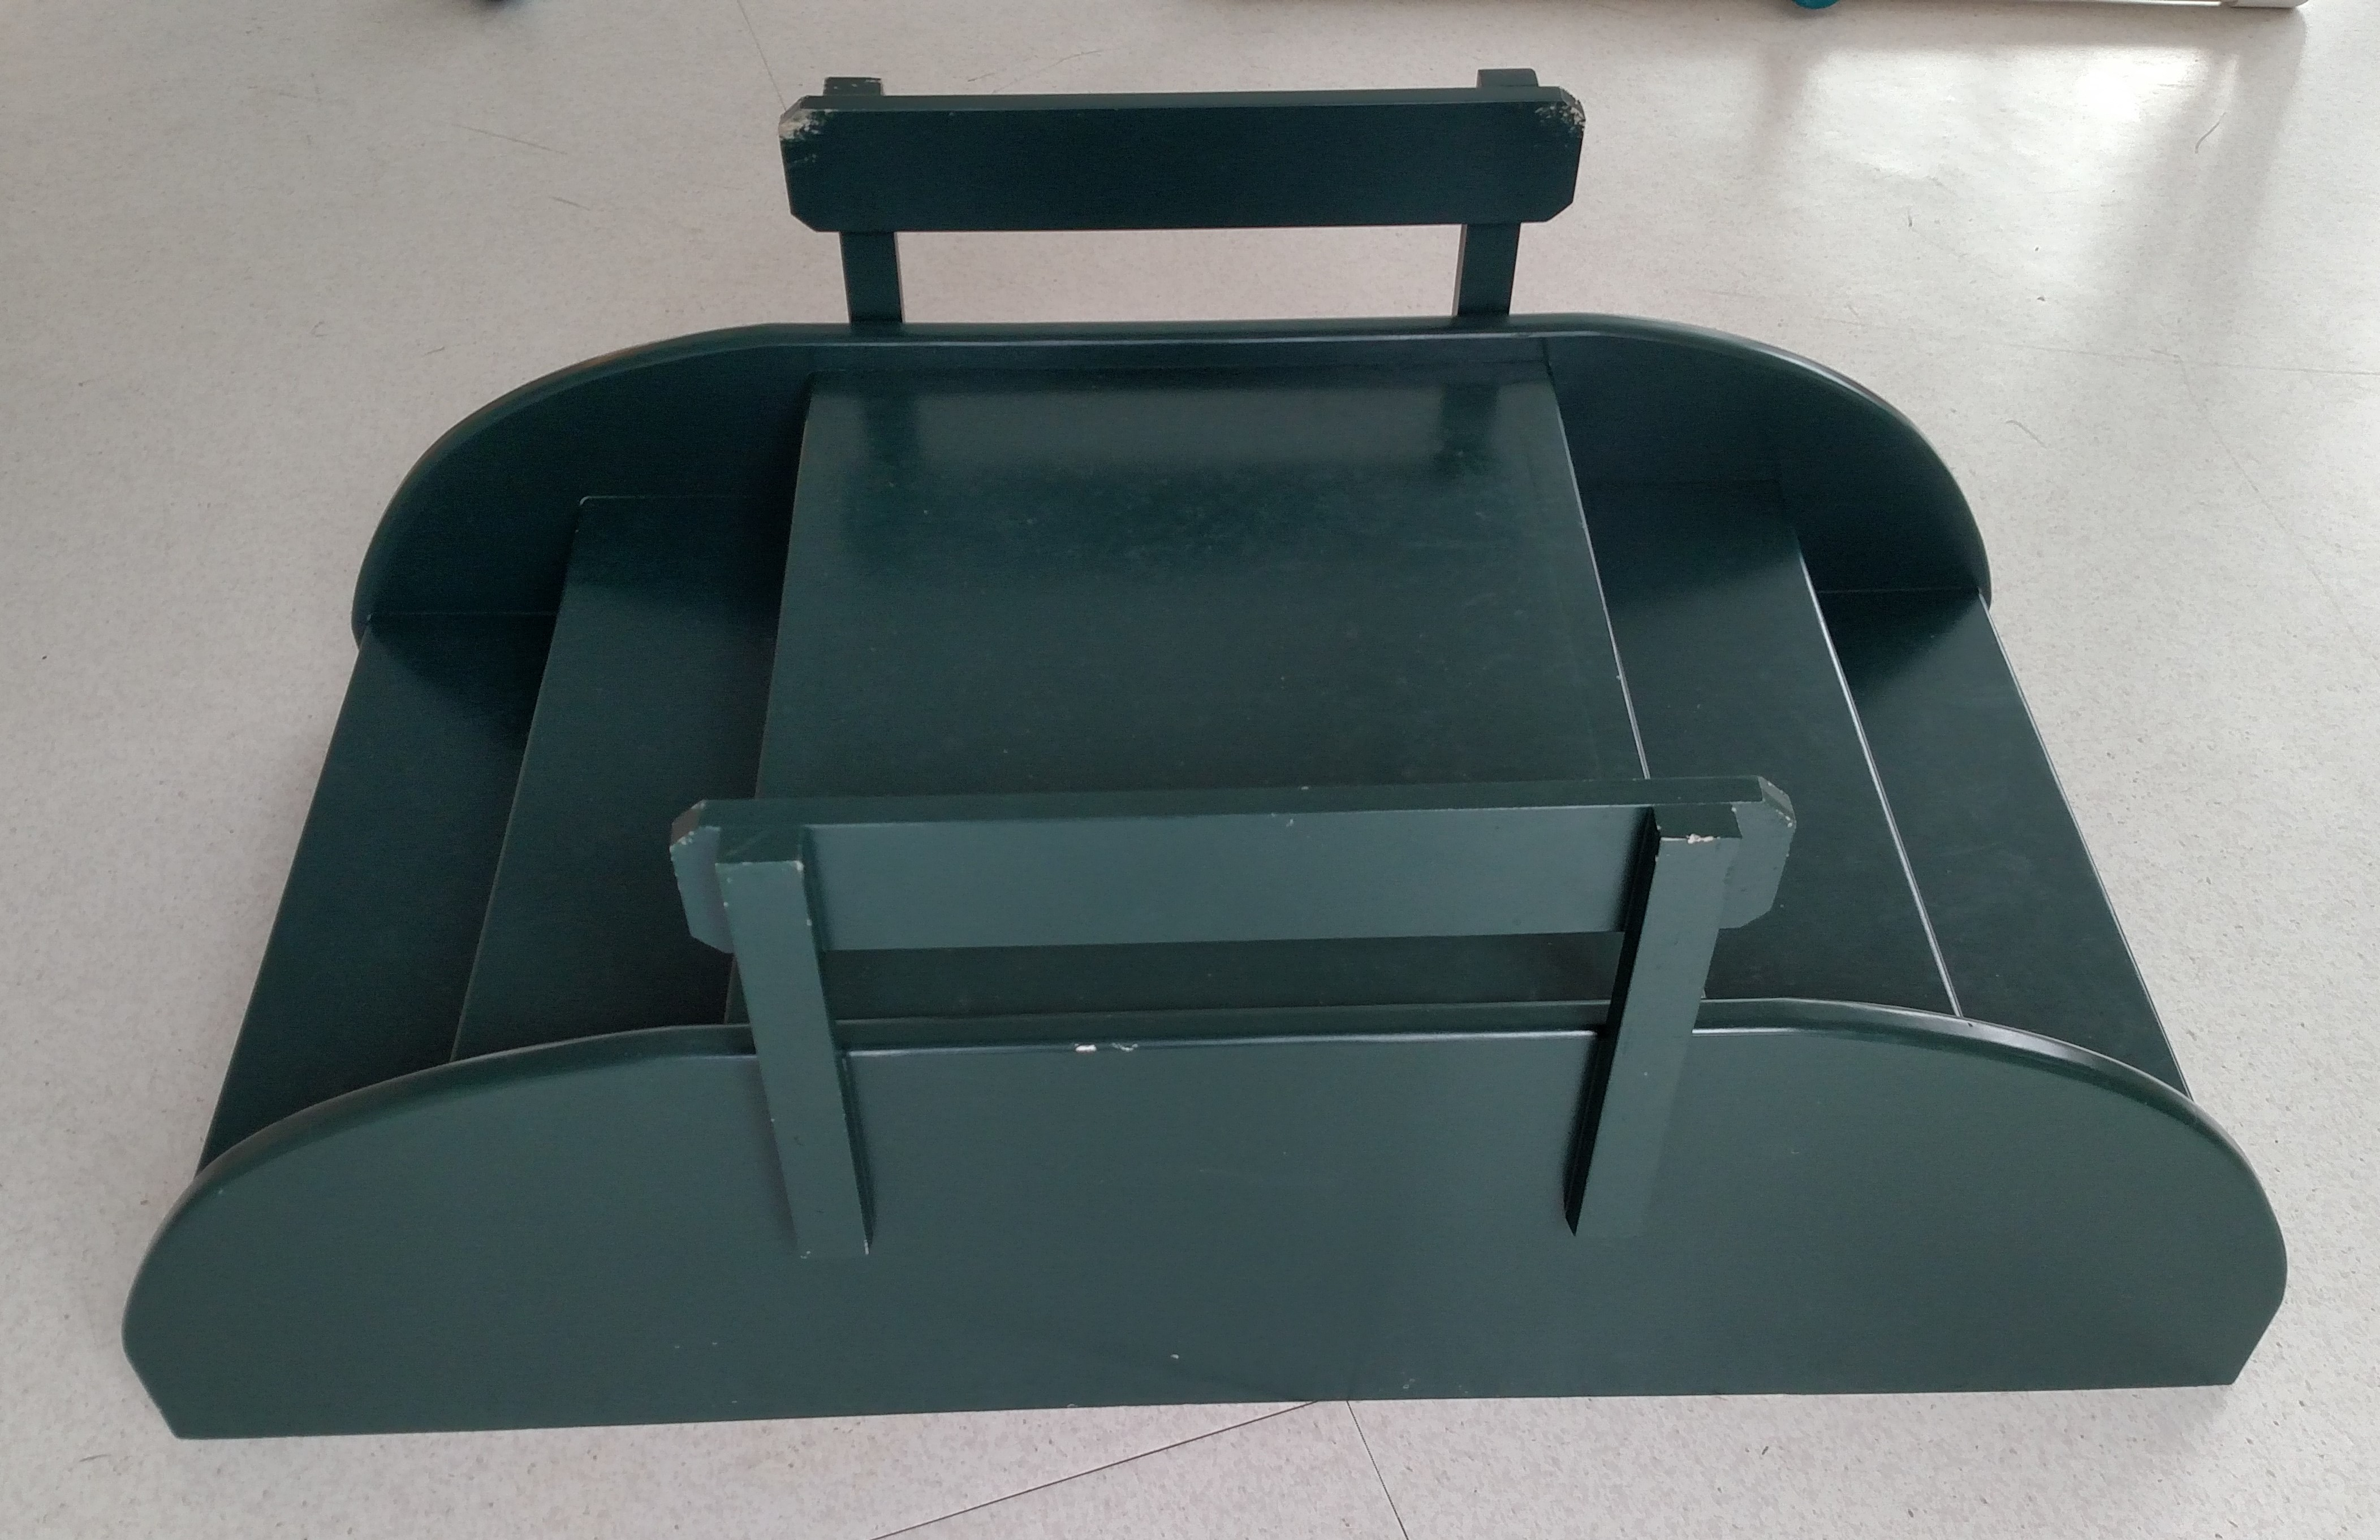
- Small dog harness the puppy can wear (handmade pup harness) 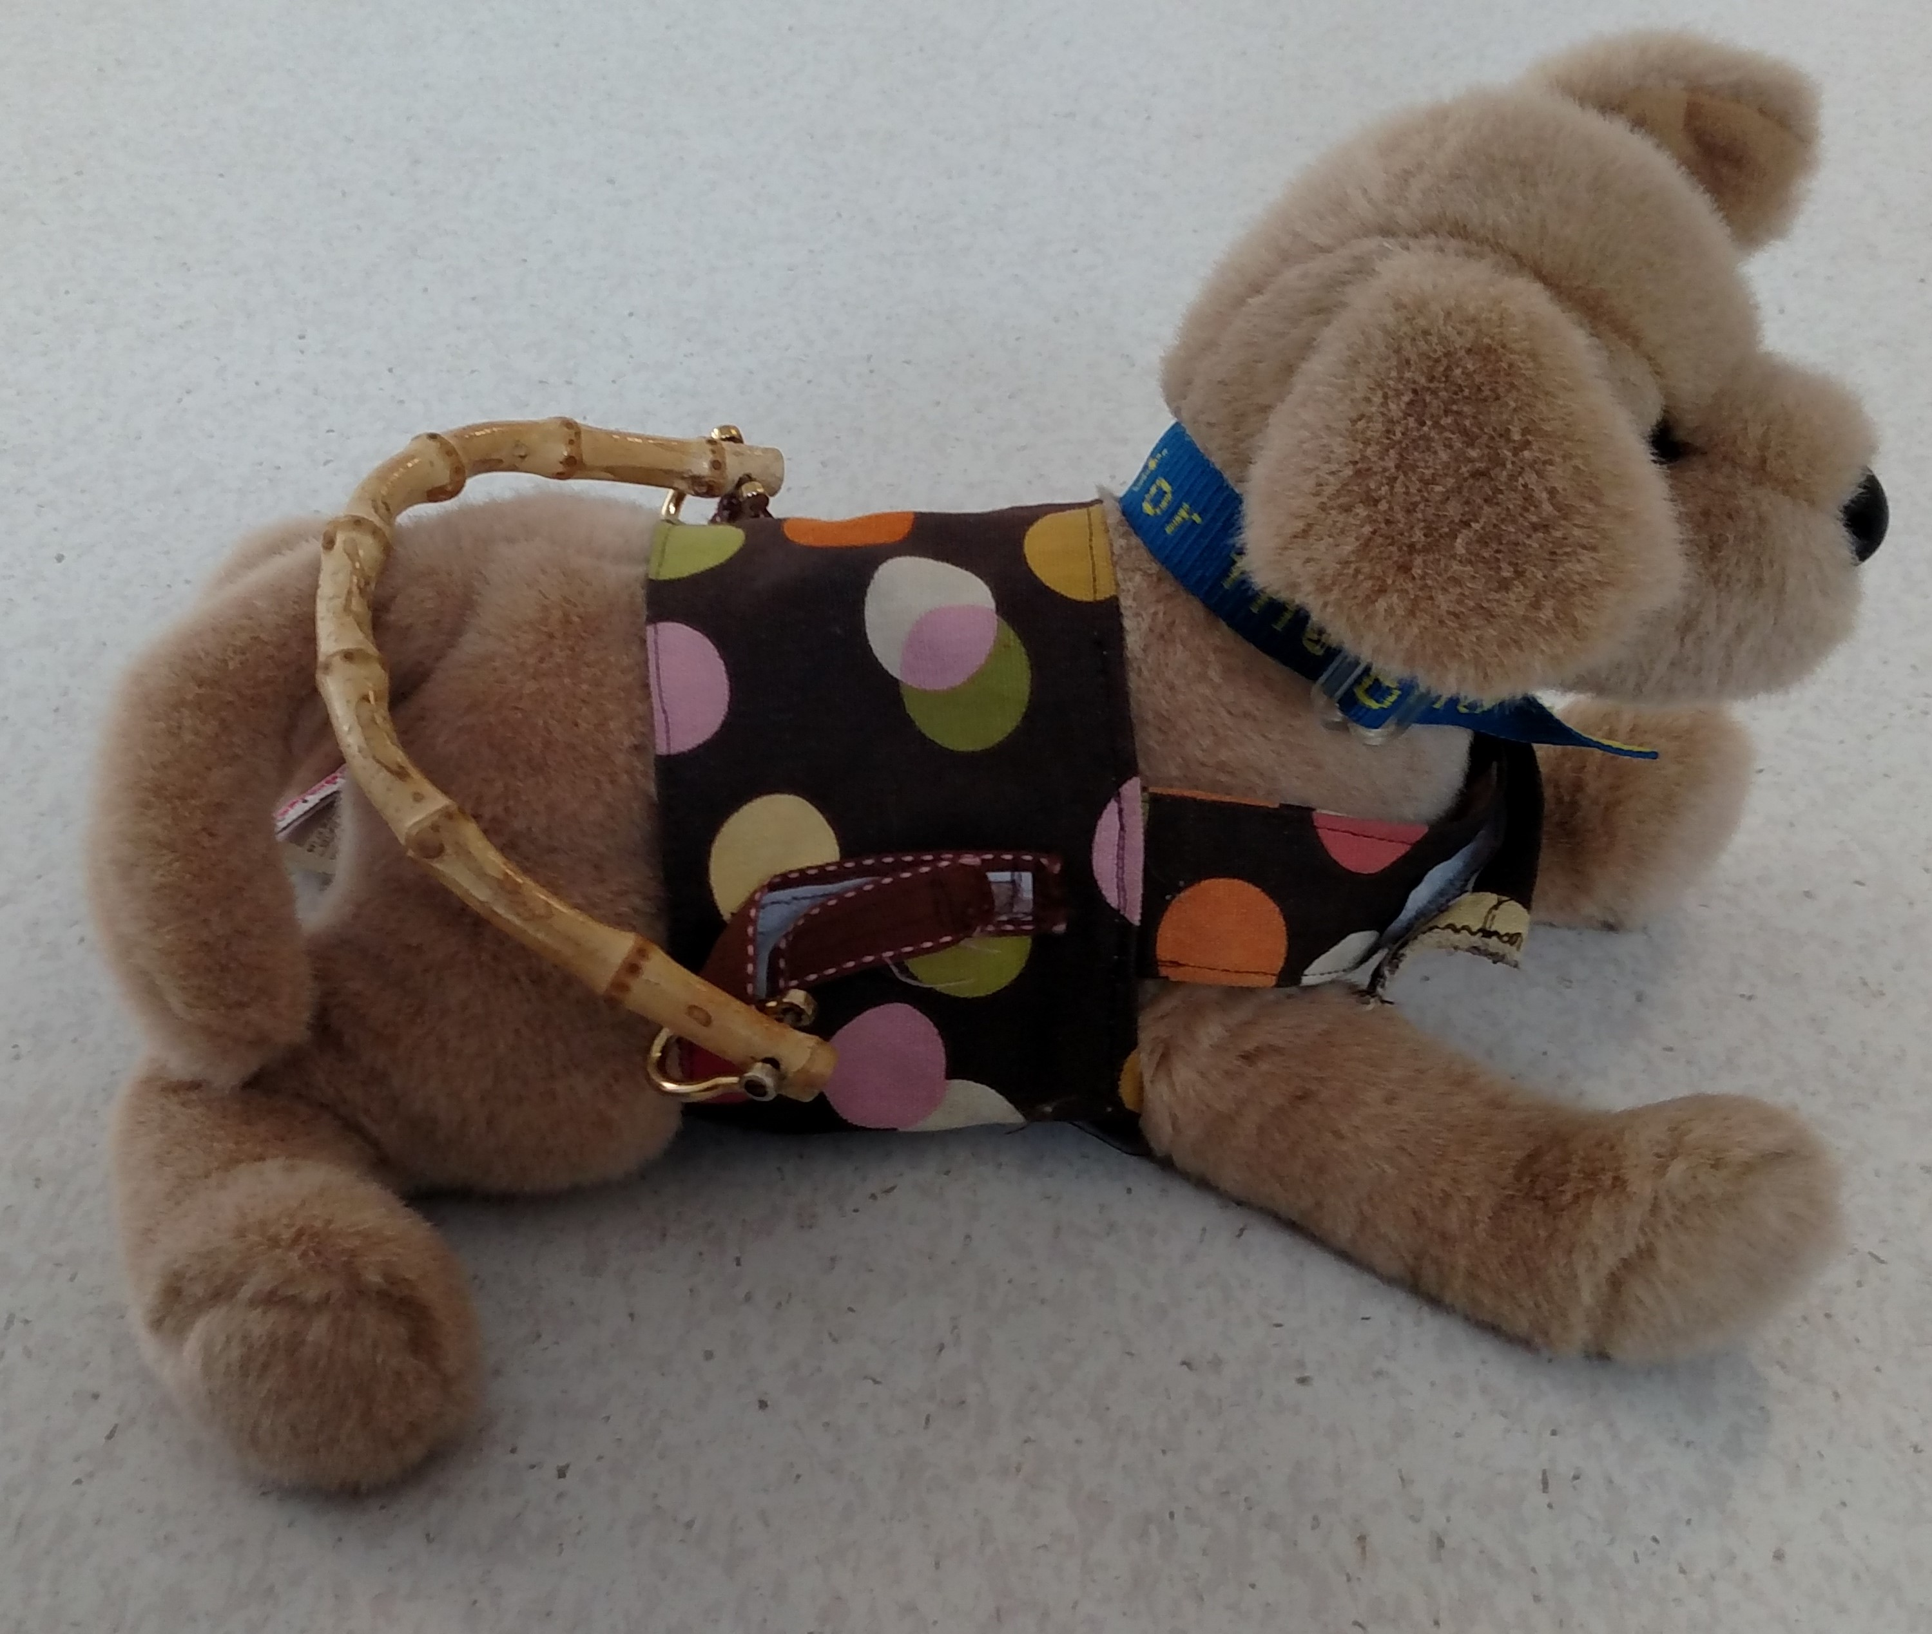
- Noise: Loud vacuum cleaner, rocks in metal container 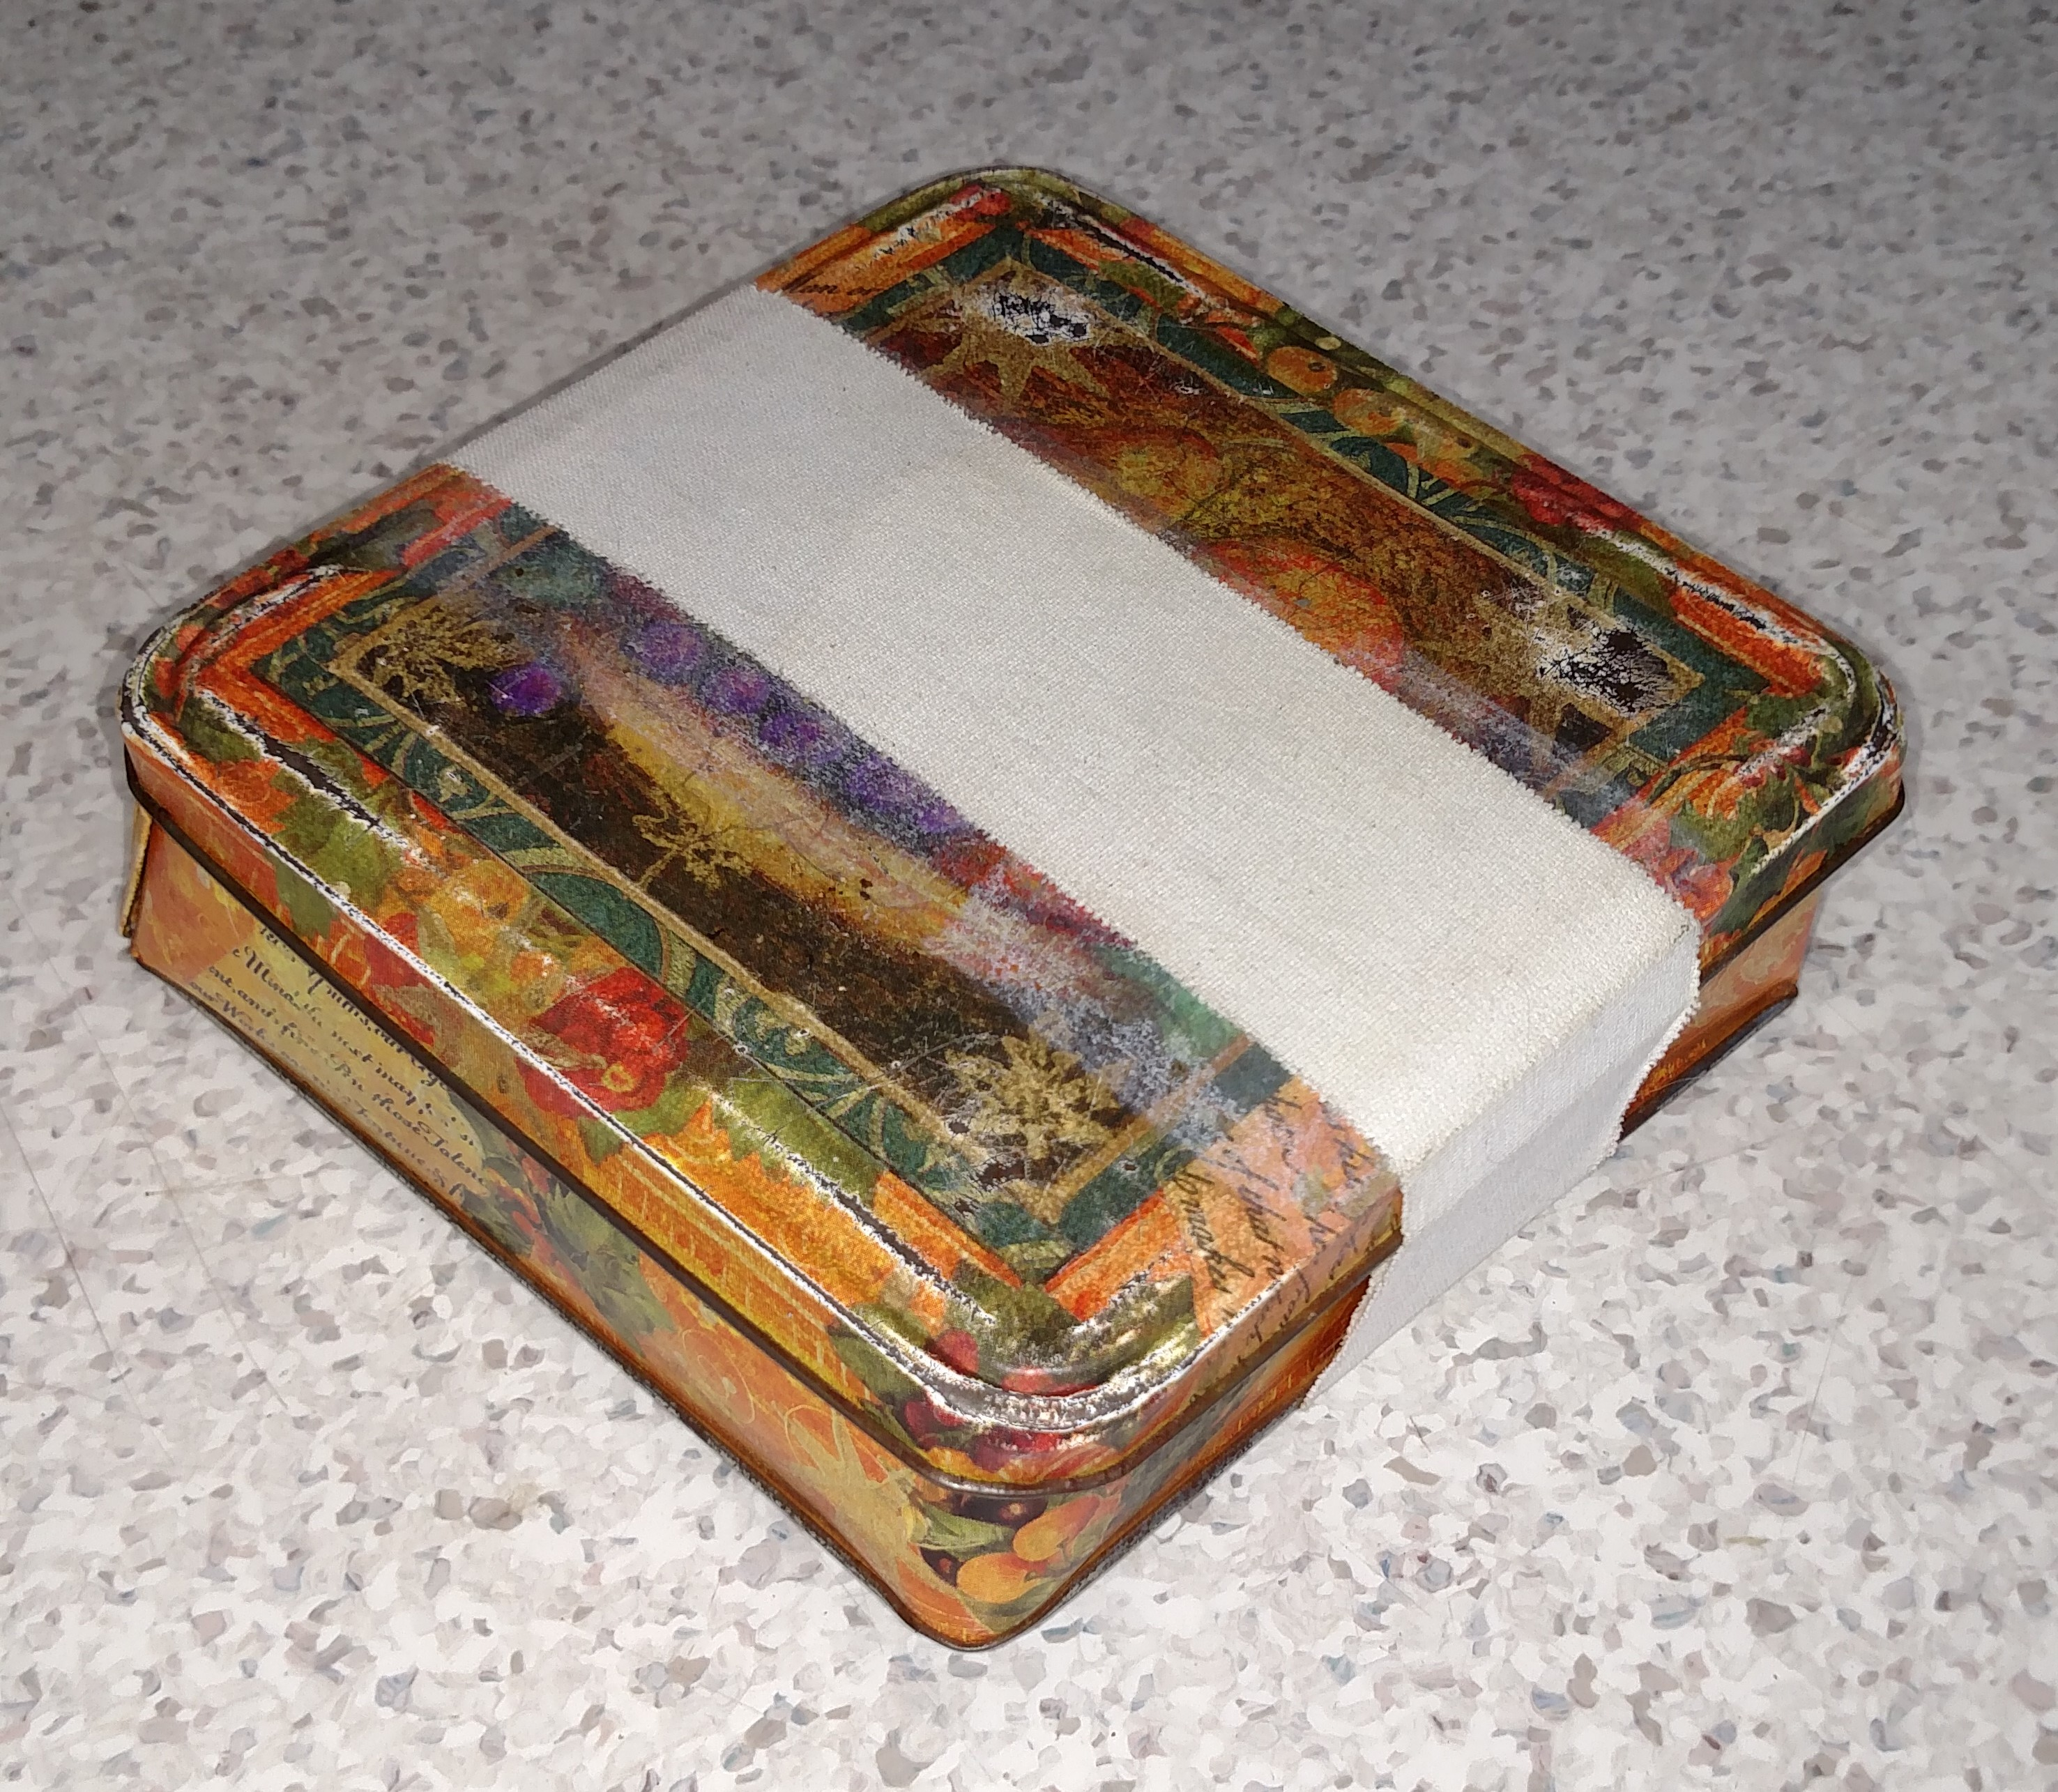
- Dry mop 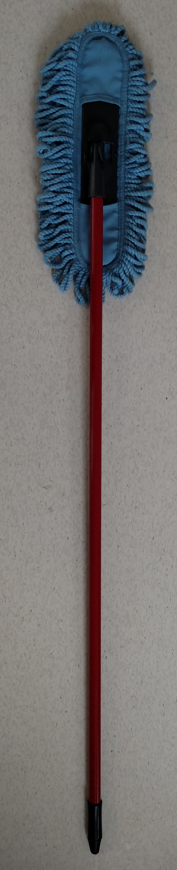
- Umbrella – smaller size that is automatic open 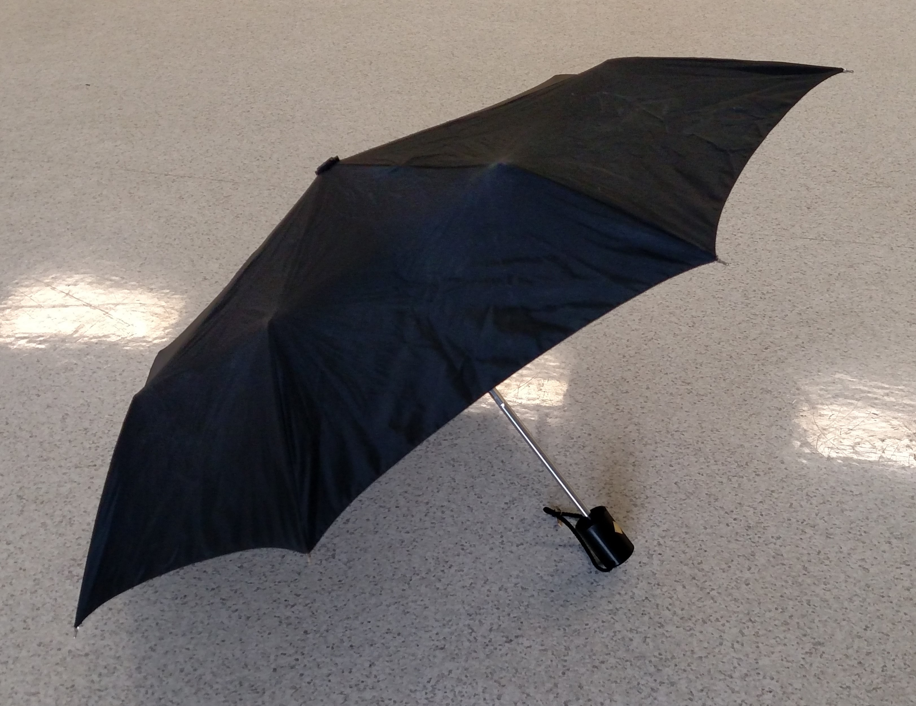
- Heights - Storage box 36” high, with grey mat placed on top to provide traction for puppy.
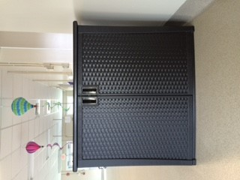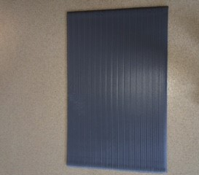

People required: 3 (Handler, videographer/prop person, and BCL scorer)
1. Handler – should be skilled in dog handling and communicating with dog
2. Videographer/prop person: turn on vacuum, drop can
3. BCL scorer/prop: turn on fan

Test time = most pups about 12-18 minutes. The test places stress on the dog to assess changes in the emotional state. Welfare of the dog must always be a priority. Modifications should be made in handling the dog wherever needed to adhere to the welfare needs of the dog.

Testing space is set up as noted in diagram. No objects are on, no people in the space. Passive items include:
Dog statue, Small rabbit (something with big eyes and 30-40 cm tall), Angel statue, Yoda, Alligator
storage
stairs
tunnel
rabbit

mat
Neutral space
angel
dog
video
fan
yoda
vac
Time |  | Procedure | Problem Solving
1 ½ minutes | New Situation/  Explore | Handler scans for avid, enters test space from the front left corner, places puppy into the center, exits space and moves out of pup’s sight. | Observe behaviour.
 | person greet | Handler enters the test space at the same entry, takes 3 to 4 steps toward center, facing toward the pup. Handler crouches down without any comments and waits for the pup to come greet them. Handler greets pup with soft happy voice and gentle petting, starting at the head. If pup does not come within 5 seconds, lightly clap hands and call pup. If pup comes greet the pup as previously stated. | If pup still does not come, handler walks 3 steps closer to pup, crouches and calls again. Repeat until you reach the puppy. Once the pup comes to the handler, or the handler reaches the pup, greet with soft happy voice and petting.
 | Taking food treats | Handler provides 3 treats slowly, allowing about three seconds per each treat, while giving verbal praise. | Observe how softly pup takes food treats. Also, it helps establish value and beginning of a relationship with the handler.
10 sec | Wait | Handler ignores, stands quietly without interacting with the puppy for 10 seconds. Once 10 seconds is up, handler can stroke the pup once again. | Watch for demand barking.
 | Follow me | With voice and hand gestures, handler encourages pup to follow in a clockwise direction toward the rabbit statue. Praising pup for following. | Observe if pup is social, follows, and is excitable with handling.
 | Fan | Person scoring turns on fan to level 2. From out of air flow handler encourages the pup to follow on the left side of handler against the x-pen using hand gestures and praise. The pup should move along the x-pen at a distance of 12”. Handler should pause to allow pup to investigate fan without handler support. Once the pup has habituated itself to the fan, loop back around to walk past the fan a second time. Fan is then turned off. | If pup will not walk past fan the first time, handler allows pup up to 5 seconds to investigate then tries walking past again at a greater distance (2 feet further away). If pup still won’t, handler squats 2’ away from fan and calls pup to come. If pup does come, handler moves 1’ away from fan, squats and calls pup. If pup does not come take three steps closer to pup and call. Repeat until you get to the pup.
 | Stairs/ramp | Handler encourages the pup with hand gestures and praise to follow, leading up the stairs and down the ramp. Can pup do alone, with handler support needs food? | If pup does not come, take three steps closer and call to the pup. Repeat until you reach the pup. If pup does not come down stairs, tap the ramp or stair to encourage them. If there is no movement, handler can encourage with food.
 | Tunnel | Encourage pup to walk through the tunnel by tapping the tunnel and using hand gestures or tossing a small soft toy through the tunnel. | Observe the outlet if the pup tries to run around the tunnel. If pup does not go through the tunnel, try to encourage a second time by tossing the toy through the tunnel again. If the puppy refuses, move on to the next event.
 | Under footings | Proceed to have pup go over both under footings (UF) with the UF and pup to the left of handler. Solid UF 1 first, then Grate UF 1 second. Gesture with hand moving across under footing to encourage pup to follow. Make it clear what you are asking. Encourage the pup to follow in a loop leading back to the first UF. | If pup does not walk on UF, handler tries up to 3 passes walking past UF while hand gesturing for pup to walk on it. Encouragement should be hand gestures and praise or a soft toy to encourage the pup. On the third try the handler can use food.
 | UFs repeat | Encourage the pup to go over both under footings a second time. Solid UF 2 then grate UF 2. | Same steps as UF
Varied time | Vacuum 1 & 2 | #1Handler and pup are near far corner (2 window walls meet). Once handler gives the cue, video person turns on the vacuum for 5 seconds. During the 5 sec time the handler is stationary, wait for the vacuum to silence. #2 Handler cues the vacuum on and walks toward the vacuum and stands just to the side of vacuum. Handler crouches and calls to pup immediately (while the vac is on). If pup comes directly to vacuum it can be turned off. | If the pup does not come to the vacuum, or handler, crouch and call while the vacuum is off. If pup still does not come, take three steps closer and call. Repeat until you reach the pup. If the pup comes, encourage them to follow to the vacuum. If the puppy has already explored the vacuum do a name response and move to the can drop.
30 seconds | Havlena Harness | Handler calls pup. Place harness over and secure under belly. Handler encourages pup to walk around space. Harness remains on for 30 seconds. | this is for body sensitivity.
 | Umbrella 1 | The handler opens the umbrella when the pup is looking and no closer then 3’ from pup. Place on ground with the inside of umbrella facing the pup. Pup comes to investigate. Handler picks up umbrella and closes again inside facing the pup. Handler places closed umbrella on floor for pup to investigate. | Observe behaviour. If pup doesn’t approach, the handler crouches on the opposite side of the umbrella and calls to pup.
 | Umbrella 2 | Repeat as above. | Observe behaviour. – Same as with umbrella 1.
 | Can drop | Handler and pup are directly in front of the videographer. Handler encourages the pup to follow toward back of space so the pup is facing away from videographer who drops the can when the pup is 6’ and from the height of the x-pen. | Observe behaviour. If pup does not come to the can within 10 seconds, then the handler walks behind the can so the can is between the pup and the handler, kneels, taps the floor and calls the pup 3x.
 | Can shake 1 | Handler will crouch down and take the can, one foot away from the pup. Shake the can three times, gently set it on the ground and remain crouching for 10 seconds. | Observe behaviour. If pup does not come to the can within 10 seconds, then the handler walks two steps behind the can so the can is between the pup and the handler, kneels, taps the floor and calls the pup 3x.
 | Can shake 2 | Repeat – Handler will take the shaker can and crouch down one foot away from the pup. Shake the can three times and set it on the ground and remain crouching. Leave the can on the ground in the testing space. | Repeat as previously stated.
 | Movement mop | Standing in the neutral zone the handler moves mop in 180 degree arc in front of themselves. The first rotation (back and forth) is on the ground and smooth. The second rotation is lifted about six inches off the ground. The handler should move the mop back and forth in a “jiggling” motion. | Observe pup’s interest in movement. Keep moving the mop as well as you can. If pup latches on, disconnect and continue movement.
About 15 sec | Elevated surface/ Heights | Go to the pup wherever it is and pick it up. Place pup on the center of the storage container which is in the front left of testing space. Handler allows 5 seconds for pup to acclimate and then encourages pup with voice and hand gestures to walk along the long edge then walk back. | Watch for evidence the pup is concerned with heights
 | Exam | While pup is on the elevated surface. Allow the pup about 5 seconds to relax. Handler will perform an exam. Gently lift each ear flap and check each eyelid. Lift the pup’s lips on both sides and then each foot. Finally, lightly restrain pup and mimic a blood draw. | Watch for body sensitivity/issues with restraint. If the pup is extremely tense, do the exam on the floor.
 | Positive ending | Handler interaction with puppy can consist of play or petting and praise to provide a release for the pup and end the test with a positive feel. | Observe if behaviour changes with handler support, also allows for more positive conclusion of test.

General comments:
- The handler interacts with the pup using the pup’s name, providing verbal and physical praise and rewards that are appropriate for your program. Occasional food rewards are acceptable if this is part of your program. (GEB is avoiding food use for this test unless it is considered necessary).
- If pup cannot complete a test component within the time or protocol, proceed to the next item.
- If the pup is not willing to approach or work with the handler or is running around in an uncontrolled manner for more than 2 minutes despite efforts to connect with the pup, the handler can use an appropriate method to reconnect with the pup. Attempt to continue the test but if the pup is unable to respond, proceed to the next test item.
- If the pup shuts down or it is deemed inhumane to continue the test due to stress reactions, the entire test should be stopped.
- If at any time the pup is not productive (falls out of the think and learn zone) allow time and, if needed, support to allow the pup to return to a productive state. The 15 second waiting periods are to provide the pup who is inhibited time to regain their composure and can be used after any event in the test.
- If the puppy eliminates, stop the test, clean up, and continue the test where it was left off.

